 | Scene | INT/EXT | Set | Actors | Lighting | Time | Length | Continuity | Costume
Day 1 | SCENE 4 | INT MORNING | Breakfast table | Roger Alice | Daylight int | 8:00 | short | none | R1 Al1
7 Dec | SCENE 7 | INT MORNING | Breakfast table | Roger Alice | Daylight int | 11:00 | short | none | R1 Al2
 | SCENE 2 | INT MORNING | Bedroom | Roger Adler | daylight int | 14:00 | short | Scene 3 | R2 Ad1
 | SCENE 9 | INT NIGHT | Bedroom | Adler Alice | Evening int | 16:00 | short | none | Ad2 Ad4 Al3
Day 2 | SCENE 1 | EXT DAY | Lough Dan, Co Wicklow | Alice bus stop | Daylight ext | 8:00 | long | Scene 3, 10, 7 | Al4
8 Dec | SCENE 3 | INT AFTERNOON | Arrival | Roger Adler Alice | Daylight int | 13:00 | long | Scene 2 | Al4 R3 Ad3
 | SCENE 5 | INT NIGHT | Living room | Roger Adler Alice | Evening int | 17:00 | long | Scene 6 | R1 Al5 Ad3
 | SCENE 6 | INT NIGHT | Living room | Adler Alice | Evening int | 18:00 | short | Scene 5 | R1 Al5
Day 3 | SCENE 1 | EXT DAY | Lough Dan, Co Wicklow | Landscapes | Daylight ext | 7:00 | short | none
9 Dec | SCENE 10 | EXT DAY | Forest | Roger Alice | Daylight ext | 10:00 | short | Scene 1 | R3 Al4
 | SCENE 8 | EXT DAY | Doorway | Roger Adler | Daylight ext | 13:00 | long | Scene 7 | R1 Ad4
 | SCENE 11 | INT NIGHT | Breakfast table | Roger Adler | Evening int | 16:00 | long | none | R3 Ad4

Our Kind Shot Breakdown

 | SCENE 1 | EXT | Costume | Action | Props
1.1  -1.7 | 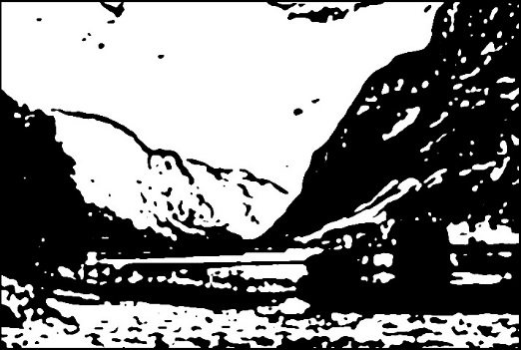 | Hardangerfjord, Norway  Several long landscape shots of fjord mountains and lake |  |  |  | TBA
1.8  1.9  1.10 | 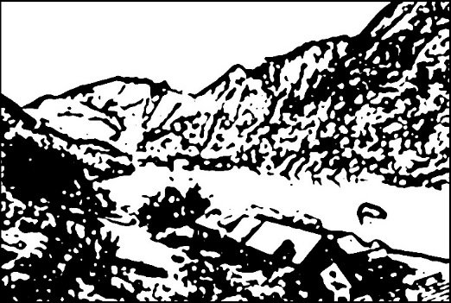 | Lough Dan, Co Wicklow  Long shot of lake from high and low vantage points.
1.11  1.12  1.13 | 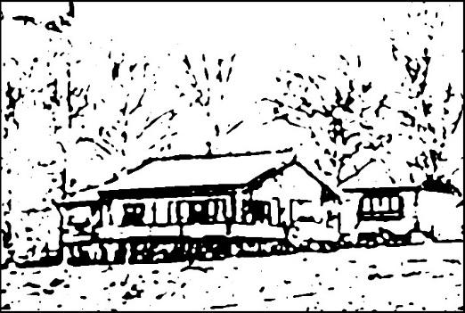 | Wooden cottage, Lough Dan, Co Wicklow  Also shots of the forest and Alice at bus stop and bakery | Alice Al4  – two different hats | Alice walks from bust stop (arrival)  Alice exits bakery with bread | Loaf of bread  Suitcase and handbag | Bus Stop arrival  Scene 3  Bread for Scene 7  Forest, Bus Departure  Scene 10

 | SCENE 2 | INT MORNING | Costume | Action | Props
2.1 | 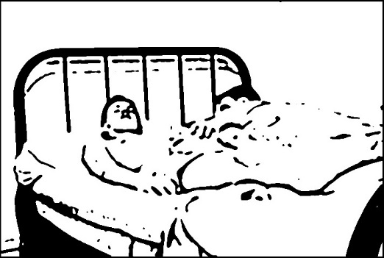 | Bedroom  Available lighting from glass walls and windows – maybe need a light outside | Roger R2  – vest, y-fronts  Adler Ad1  – vest, y-fronts | Roger under blanket with head on white pillow. He wraps his arm around Adler and gives his a gentle squeeze. After dialogue Adler gets out of bed goes to other room (left) | Brown blanket, grey/off-white sheets and pillow  Eiderdown?  Blanket with ticking
 | “OUR KIND” | CU hands
2.2 | CU of hand on body or closer on bed after Adler has gotten out

 | SCENE 3 | INT DAY Afternoon | Costume | Action | Props
3.1 | 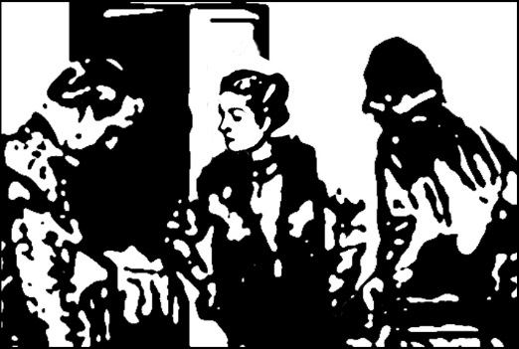 | Front door  Lighting inside only  Character in silhouette against open door and window okay | Roger R3  - tweed suit  Adler Ad3  – jumper  Alice Al4 – heavy coat – hat Lilly Dache | Door opens, Roger and Alice come in and come from outside | Suitcase  Letter  Handbag  Drinking glass
 | “HISTORY IS NOT SO RECORDED IN OTHER LANDS” | Shut door | R3 Ad3
3.2 | CU Alice hands in handbag |  |  | Alice rummages in her handbag for envelope
3.3 | CU Roger holding up letter to read |  |  | Roger reads letter

 | SCENE 4 | INT Morning | Costume | Action | Props
4.1 | 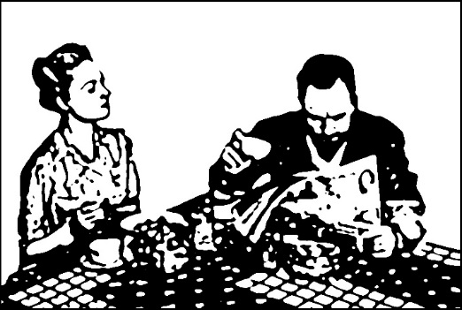 | Morning  Ext light from door side, back of Alice | Alice Al1  – skirt, blouse  Roger R1  – grey wool suit | Sitting diagonally from each other, both facing camera, Alice to the left.  Alice looking at cup, then around the room. | newspaper w headline “Markievicz Suicide - Countess Plunges to Death”  Tea cups -Minton?  Table cloth  Scandi cinnamon buns  brown cheese  Morpho butterfly
 | “THEIR DREAM AND THEIR DEATHS ARE PHASES OF A DISHONOURABLE PHANTASY” | CU hand on cup
4.2 | CU hand on cup
4.3 | CU Roger holding newspaper showing the headline

 | SCENE 5 | INT NIGHT | Costume | Action | Props
5.1 | 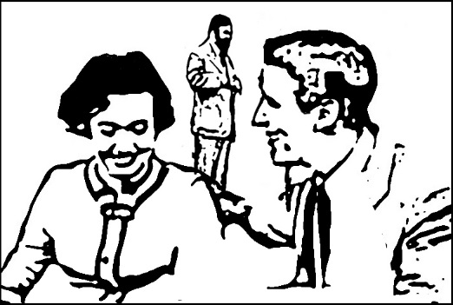 | Lighting as if from lamp stands in room – one to right and one in background right  Camera looking toward front door. Low to allow for Roger. | Alice Al5  - silk blouse, cardigan, skirt  Adler Ad3  – wool jumper/jacket  Roger R1  – grey wool suit | Alice and Adler sitting in the armchair area.  Roger enters in the background centre | tall glasses,  red wine  bottle of grappa, 3 shot glasses  coffee table  (or small table cloth for existing one)  40s lamp shades  - standard and table
 | “WHERE ALL YOUR RIGHTS HAVE BECOME ONLY AN ACCUMULATED WRONG”
5.1 | CU of hands lifting glass
5.2 | MS low looking up at Roger as he goes to get the bottle of grappa – shot to show antlers on wall behind as he goes into kitchen to fetch the bottle | MS antlers

 | SCENE 6 | INT NIGHT | Costume | Action | Props
6.1 | 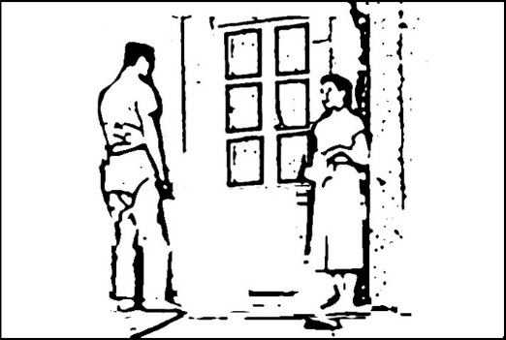 | Window black, not showing reflected light or outside | Alice Al5  - silk blouse, cardigan, skirt  Adler Ad3  – wool jumper/jacket | Alice and Adler look out, Alice begins quietly speaking. Adler points out the window. | Blood for cut hand
 | “IF TRUE RELIGION RESTS ON LOVE, IT IS EQUALLY TRUE THAT LOYALTY RESTS ON LOVE” | Over dark window
6.2 | CU Alice holds her arm in pain after hitting it against the window frame

 | SCENE 7 | INT Morning | Costume | Action | Props
7.1 | 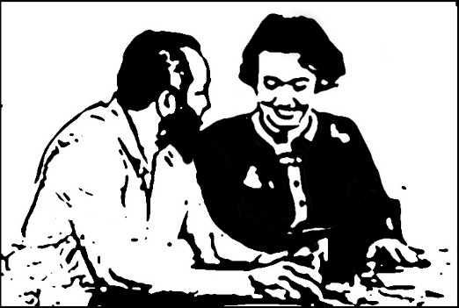 | Same table as Scene 3 – both at one side now | Roger R1  - grey wool suit plus coat?  Alice Al2  - structured jumper  Adler Ad4  – Nazi uniform | Alice sitting alone with a cup of tea, Roger comes and joins her at the table from the left. | Different newspaper  Same cups and teapot  Fresh bread from bakery
 | “LOYALTY IS A SENTIMENT, NOT A LAW. IT RESTS ON LOVE, NOT ON RESTRAINT” | Over Alice at table
7.2 | MS through window of the arrival of Adler in Nazi uniform
7.3 | Shot of Alice buying bread exiting Bakery

 | SCENE 8 | EXT morning | Costume | Action | Props
8.1 | 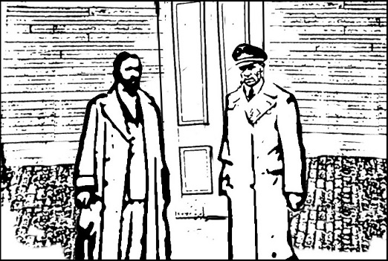 |  | Roger R1  - grey wool suit plus coat?  Adler Ad4  – Nazi uniform | Door exterior, Adler knocks on door and Roger answers and comes outside
 | “I ASKED NO ENGLISHMAN TO HELP ME. I ASKED IRISHMEN TO FIGHT FOR THEIR RIGHTS” | Over cottage door
8.2 | CU Adler for Hop-Frog story

 | SCENE 9 | INT Night | Costume | Action | Props
9.1 | 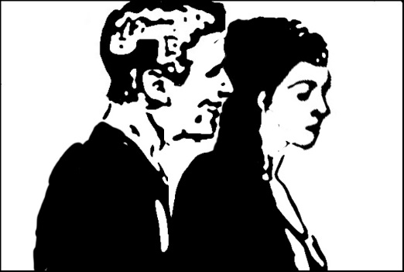 | Bedroom | Adler Ad2  – vest or no top  Alice Al3  – silk blouse, slip  Ad4 uniform on chair in room | standing behind Alice, side view getting dressed
 | “THERE IS NO IRELAND” | Across couple
9.2 | CU Adler gets closer and runs his finger through her hair

 | SCENE 10 | EXT Day | Costume | Action | Props
10.1 | 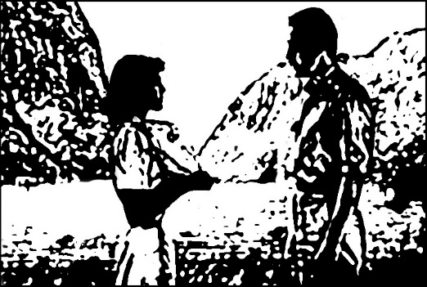 | Available light  forest  or green screen | Roger R3  – tweed suit with coat  Alice Al4  - coat plus case  Lilly Dache hat |  | Alice suitcase
 | “IT IS NOT NECESSARY TO CLIMB THE PAINFUL STAIRS OF IRISH HISTORY” | Over empty landscape
10.2 | Alice at bus stop shelter

 | SCENE 11 | INT Night | Costume | Action | Props
11.1 | 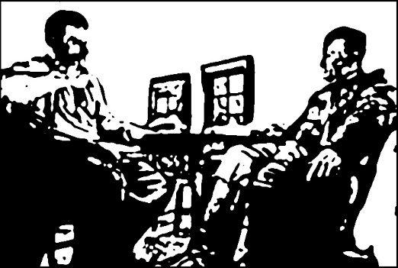 | Light from above not shown | Roger R3  – vintage shirt, waistcoat, tweed trousers suit  Adler Ad4  – German uniform | Both are sitting at the table, low angle with both at edges of frame and full in shot.  Adler slams his glass down gets up from the table and walks to the door, exiting. | Drink glasses
 | “THE RIGHT TO FEEL THE SUN, OR SMELL THE FLOWERS, OR TO LOVE OUR KIND” | Over pair at table (or not at all)
11.2 | CU Adler fills their glasses.
11.3 | CU Roger takes a drink while telling adultery story
11.4 | MS Roger left alone in the room looking dejected and confused.

