Alan Phelan Cabbage Workshops

Materials needed per person:

- Plastic sheeting to cover work table
- A4 paper - ivory or coloured, acid free quality
- Access to photocopier to make copies from newspapers
- Evcon-R glue
- Water
- Bowl/Plate for mixing glue
- Med sized paintbrush
- Scissors
- Hot glue gun with glue sticks
- Foam cone (7cm diameter at base x 12.5cm high)
- Mylar plastic sheets with leave template/shape

How to Make Cabbages:
- Newspaper clippings should be collected by participants prior to the workshop. These should be largely text with small to medium sized headlines and NO PHOTOS. The topics should be about the current financial crisis from any perspective. The amount is variable – up to 10 different articles.

- The clippings need to be taped or glued to A4 sheets – arranged with the text flowing in the same direction – filling the page(s) completely.

- The clippings pages should then be photocopied onto the archival A4 paper – single sided – about 40 pages copied for each clippings sheet.

- Select photocopied sheets in pairs – 20 sheets needed per cabbage – this will yield the 10 glued pairs needed per cabbage.

- Cover table with plastic sheeting.

- Mix glue equal part water and glue in a bowl or saucer – about 2 tablespoons glue is enough.

- With a medium sized paint brush, paint on the glue on the reverse of one A4 sheet.

- Place a dry A4 sheet over glued surface making sure the type is in the same direction on both sides – rub down with palm of hand to form a tight bond – excess glue will spill out but rub it into the paper (the glue is non-toxic).

- Leave to dry separated and flat for 1 hour in a warm room – if the glue is used sparingly the sheets can be used while still damp as they will dry fasted anyway.

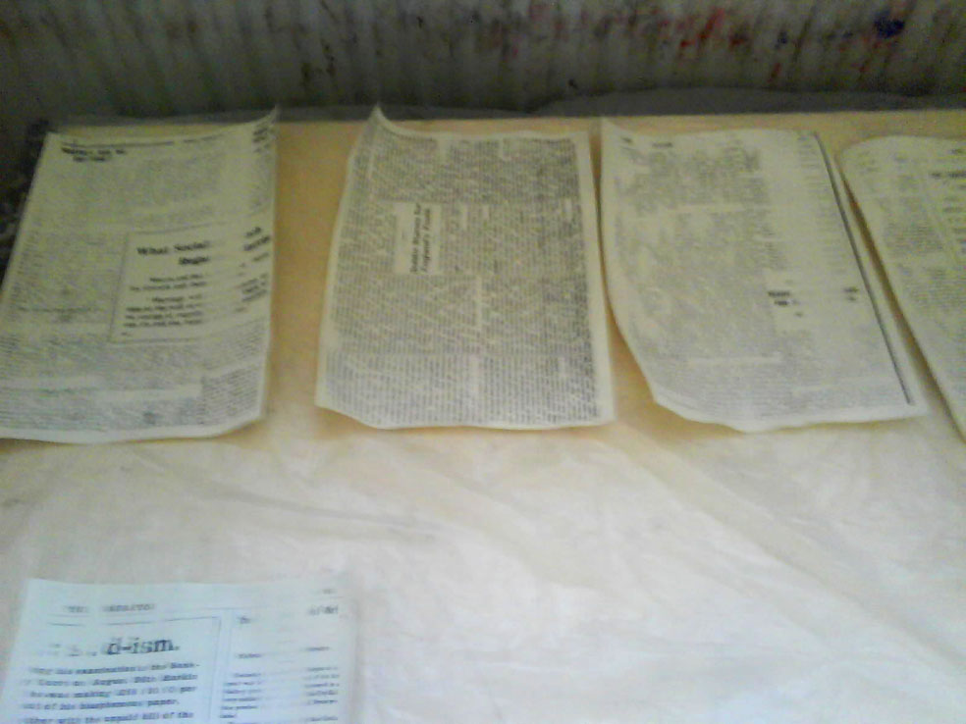

- Using the plastic templates cut out the leaf shapes from paper – there are 4 templates:

  - Small size – cut 6 leaves from 1 A4 sheet
  - Med size – cut 6 leaves from 3 A4 sheets
  - Large size – cut 4 leaves from 2 A4 sheets
  - Large size with extended flap – cut 4 leaves from 4 A4 sheet

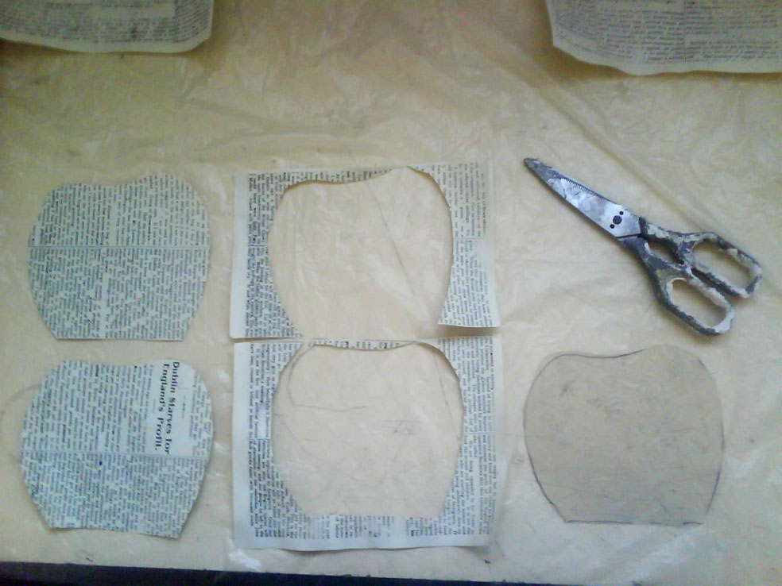

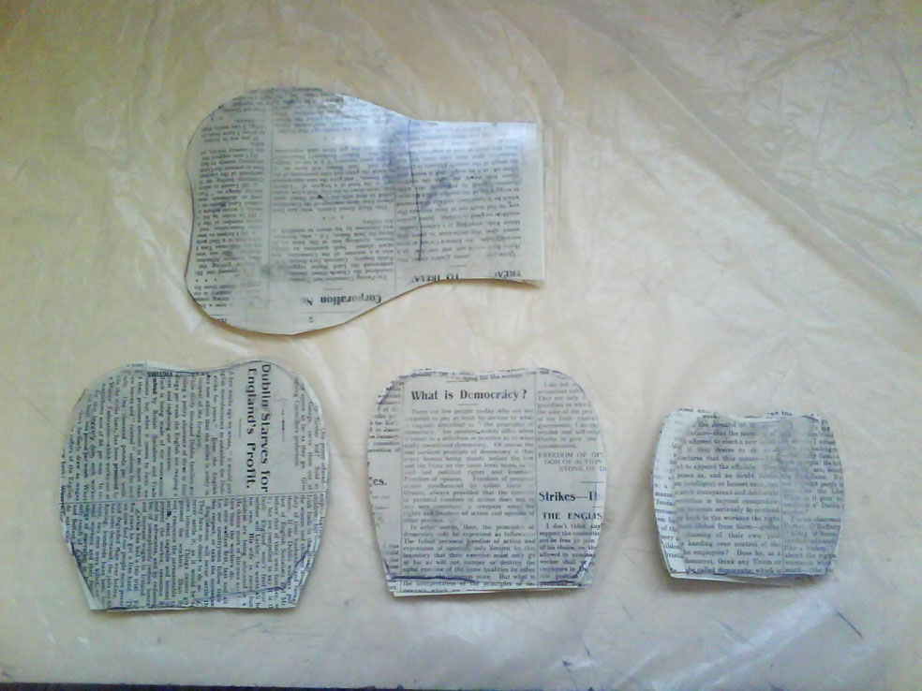

- Snip top off top of cone.

- Take a small scrap of leftover paper and wrap the top. Glue in place with glue gun.

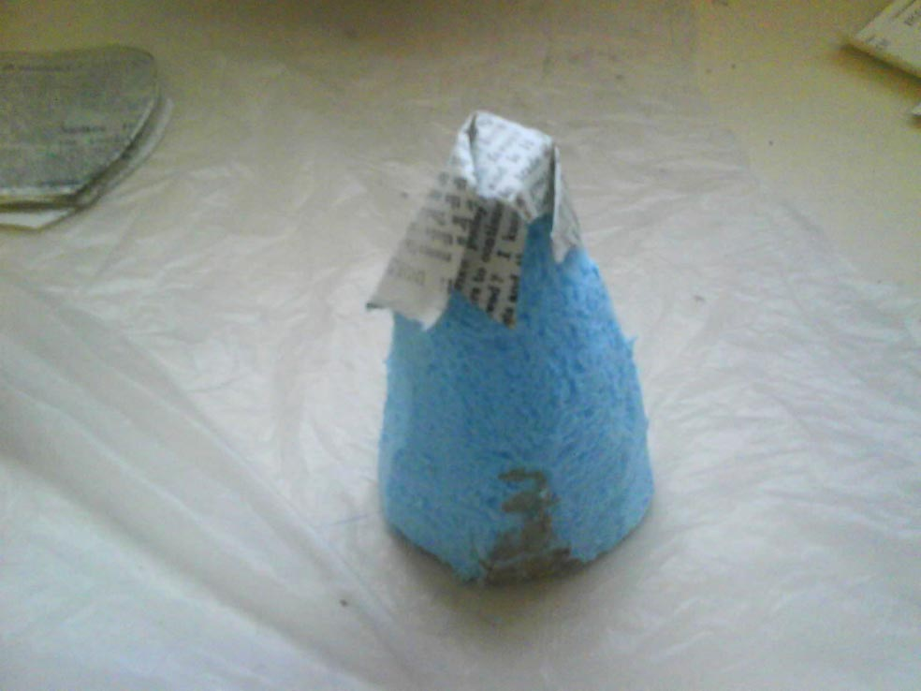

- Starting with two small leaves begin attaching leaves to the cone – hot gluing paper to paper as much as possible. Each leave position is half way through the one beneath – also the tip of each leaf should be pulled back and crinkled or scrunched (without tearing) before gluing.

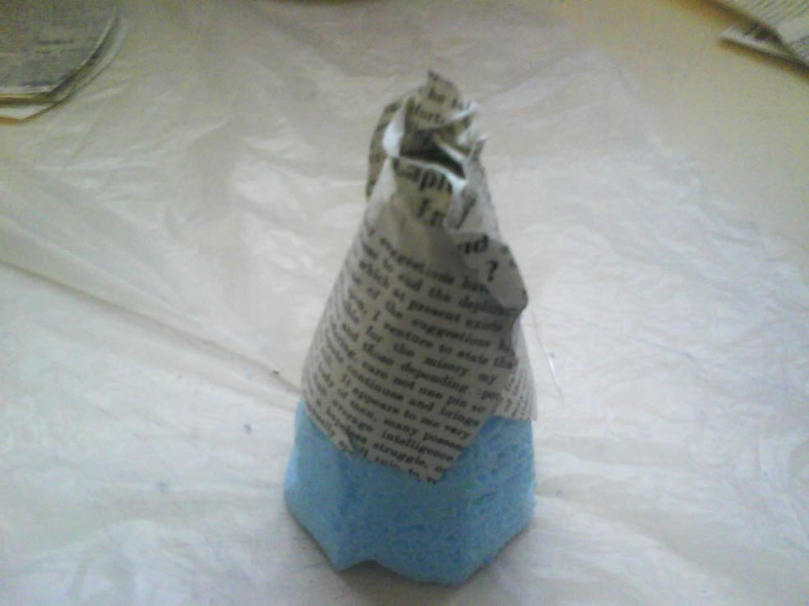

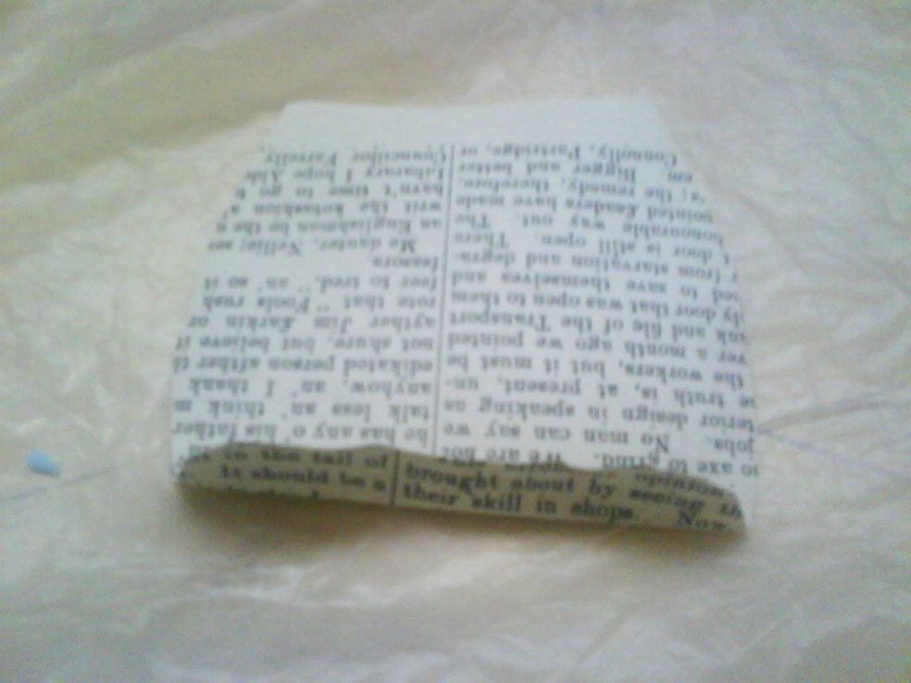

- Each leaf must be folded over loosely at the top tip, folder loosely in half (to approximate a stem) and scrunched to make it unique. This is the trickiest part of the process as it needs to be done fast and loosely so as not to tear the paper or make hard creases.

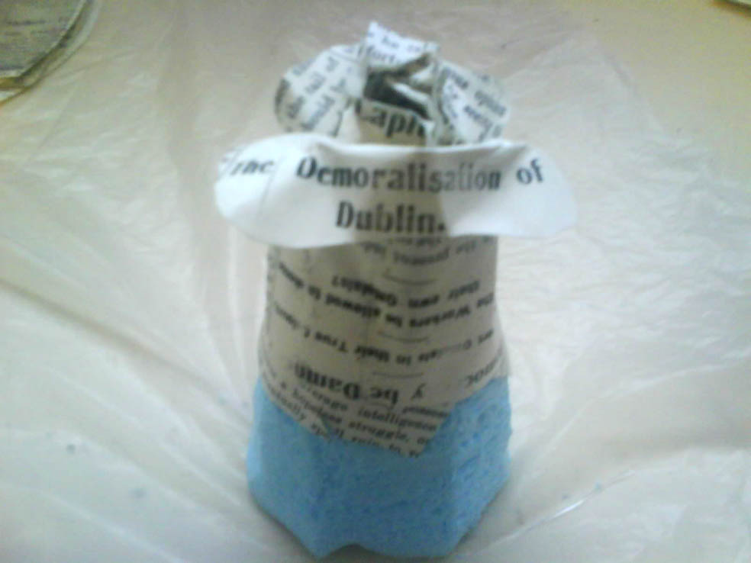

- As larger leaves are glued increase the size of the fold that the top of each leaf to ensure a wide crown. Also do not glue too tightly together – keep loose. Also aim to have the tops of the leaves at the same level to create a flat crown – this is not always possible and that’s okay as tiered leaves look like a cabbage gone to seed!

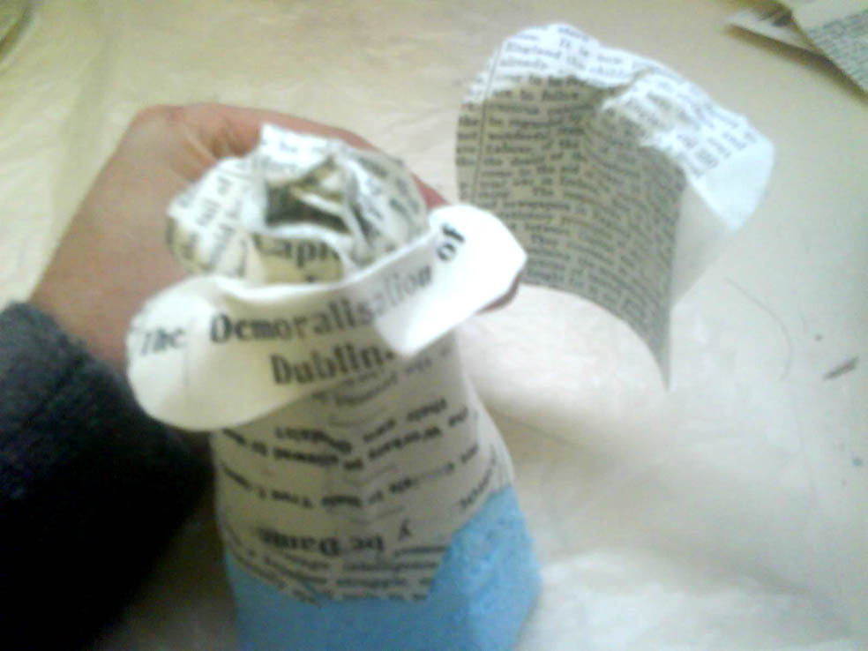
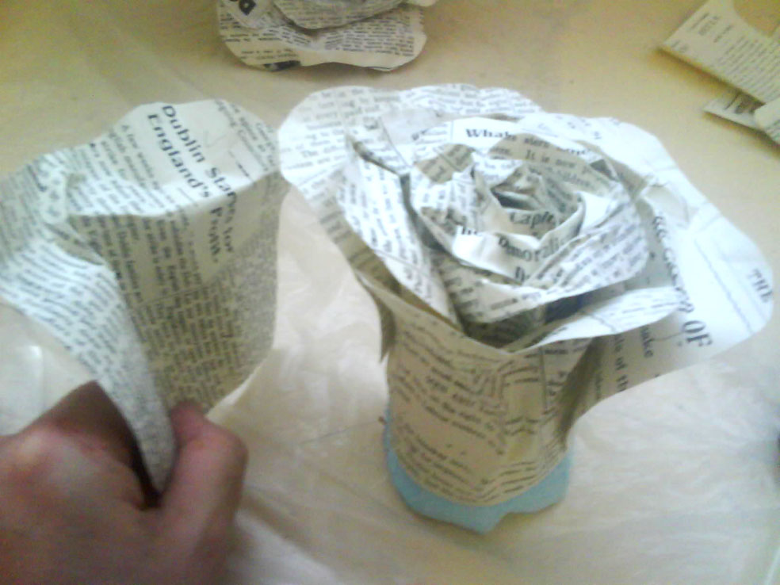

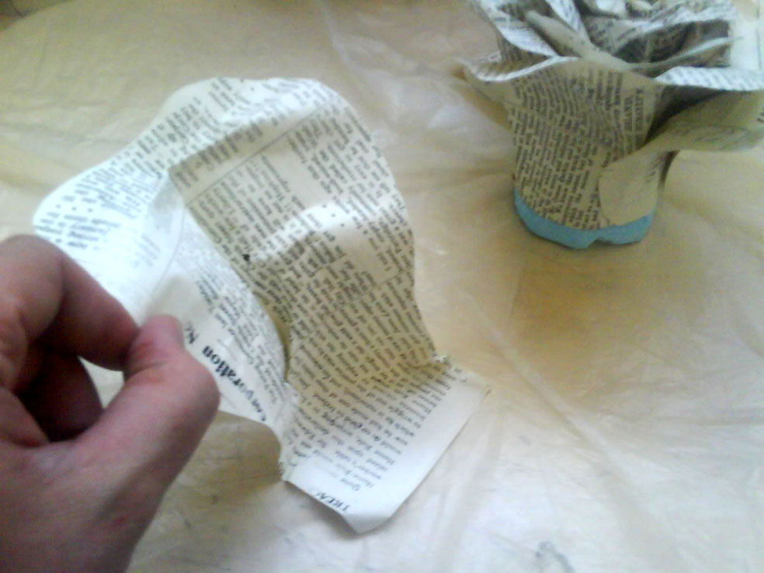

- Use the large size with extended flap to cover the exposed cone and fold over onto base.

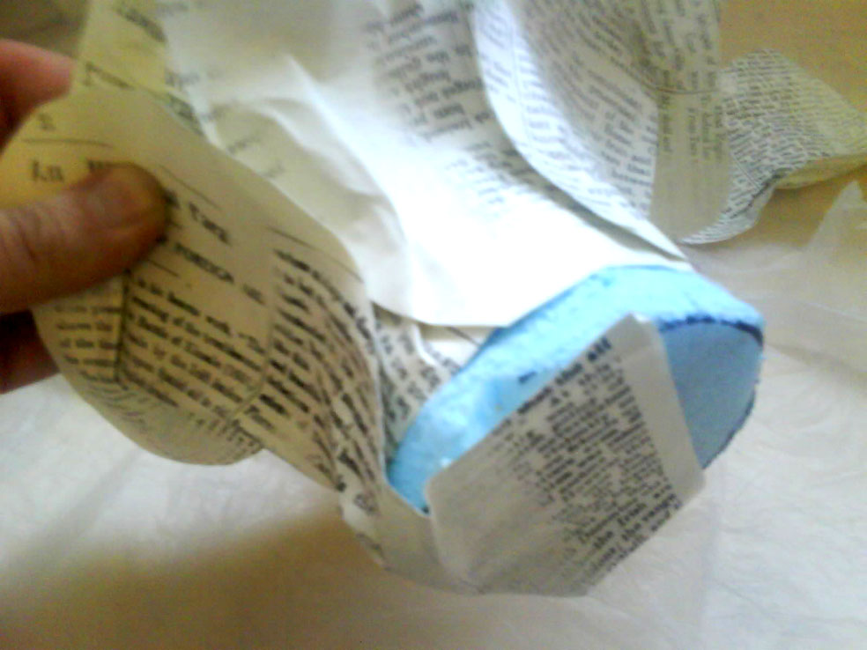

- Take a small scrape of paper to cover the base to cover up all paper overlaps.

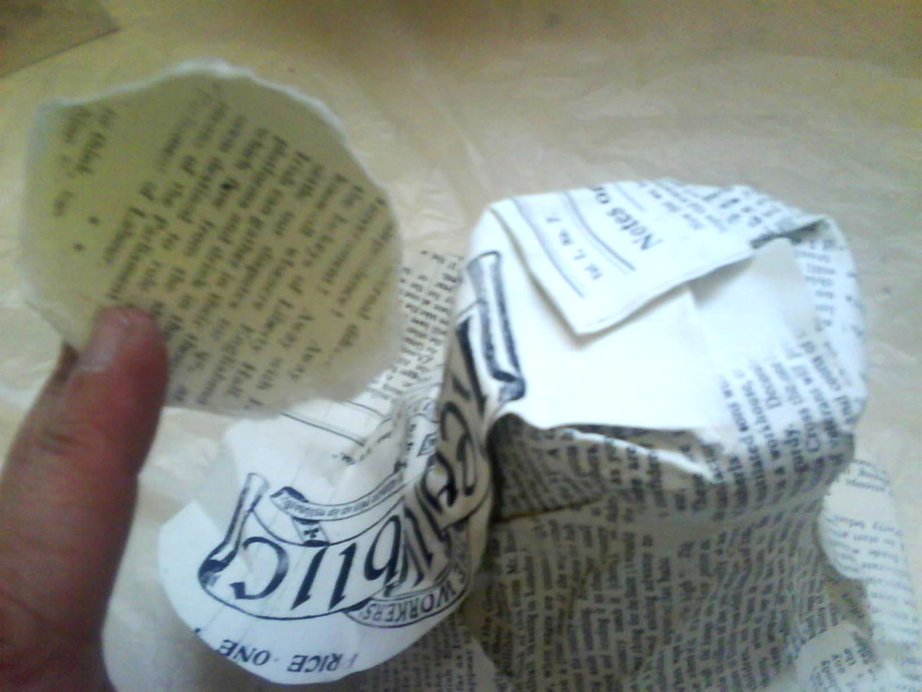

Finished!

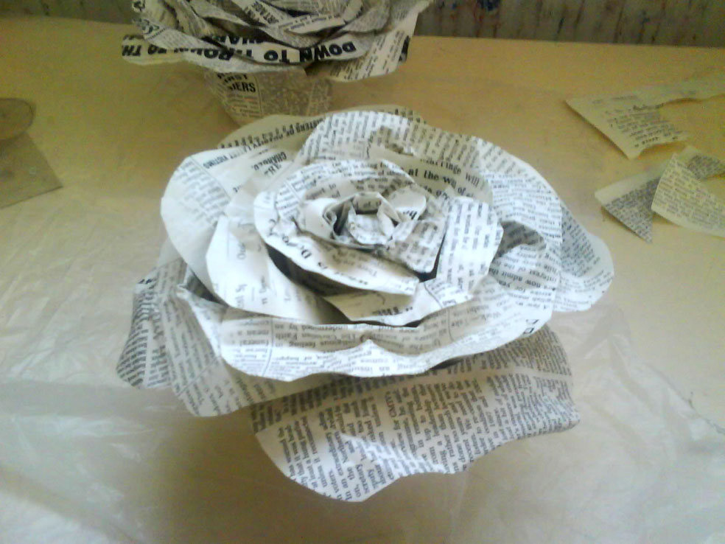

Suppliers
here are some options of suppliers and prices

Glue
best quality paper glue, not PVA (too brittle)
http://www.preservationcare.com/shop/evacon-r-conservation-adhesive
1 kg €16.95 each
need 5 = €84.75 + VAT €23.17 + shipping €16.00

Paper
what I have used previously and exclusively
http://www.cxdglobal.com/category.aspx?id=273
Heritage Archival pHotokraft Old Grey Ivory
http://www.cxdglobal.com/ProductDetails.aspx?id=273&itemno=PAHPKA0802
.03 per sheet, 500= £15.00 +VAT? +shipping? need 10
http://www.cxdglobal.com/home.aspx?pagename=howtoorder
or
(I have not seen a sample of the colour however)
https://www.vikingdirect.ie/en/steinbeis-a4-classic-off-white-80gsm-printer-paper-off-white-p-5576202
1 pack 500 off-white paper €3.99
need 10 = €39.90 + €10.33VAT + €5.00 shipping
or
coloured, ivory or off-white (never plain white)
https://www.vikingdirect.ie/en/paper-printing-c-108/printer-paper-c-10804/coloured-paper-c-10804003
1 pack 500 coloured paper €11.99
need 10 = €159.80+€36.76 VAT free shipping!

Cone
http://schoolandofficeworld.ie/POLYSTYRENE-SHAPES-POLYSTYRENE-CONES-778/
5 pack €4.95 x 20 = 100 €99 inc VAT €18.51 + shipping?
13 cm polystyrene cones

- glue gun with 10 glue sticks per participant (and other items at top of document)

